Name : Mr.K.Ramana Chandrachut

Qualification : M.Pharm

Department : Pharmacology

Designation : Associate Professor
Date of Joining : 04-06-2018
Area of Research : Neuropharmacology
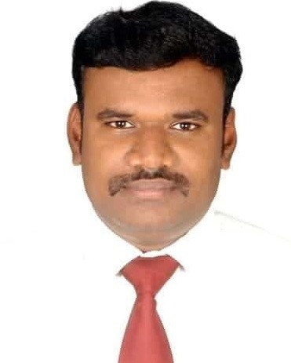

Mr. Ramana Chandrachut, M.Pharm
Associate Professor

Field of Specialization | Pharmacology
Phone No. | 9789456750
E-Mail | ramana200678jkkm@gmail.com
Residential Address | 250/2,Thoppukadu,  Alagapuram,  Salem District - 636 016
Experience | 9 Years
Blood Group | B⁺ Positive

Area of Research
➢  Drug discovery for Neurodegenerative disorders
- Drug discovery for CNS disorders

Publication Details :

National : 2

Project details :

UG : 2

Conference/ Workshop/ Symposium/ Seminar/FDP Attended : 6

